Chapter 9: Earth, Sun and Moon

9.1 The Earth, Sun and Moon interact with each other

Student worksheet answers (pages 156–157)

Earth, Sun and Moon interactions

1 The Sun is central to our existence on Earth – without it we could not survive.

a What is the Sun?

The Sun is a star.

b Describe what is the Sun is like.

The Sun is an incredibly hot and very large ball of gas (or, more correctly, plasma).

c What does the Sun provide for the Earth?

The Sun provides the Earth with heat and light.

d How is solar energy created?

Solar energy is created by atoms colliding with each other in the centre of the Sun.

e What is the solar system?

The solar system is a system made up of a Sun and the planets, dwarf planets, moons, asteroids and other celestial bodies orbiting around it.

f What is one similarity in the interactions between the Earth and the Sun and an asteroid and the Sun?

The Earth and some asteroids orbit the Sun.

2 To explain why the Earth experiences daytime and night-time, label the diagram below with the axis, equator and the poles. Also include arrows to indicate the direction of rotation and the Sun’s rays.

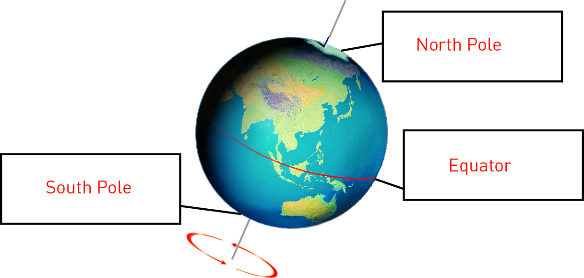

3 Which states of Australia would see sun rise:

a first?

Victoria, New South Wales, Queensland and Tasmania

b last?

Western Australia

4 The diagrams below show the position of the Sun, Earth and Moon during a solar and lunar (Moon) eclipse. The lunar eclipse is explained in section 9.1, but before you explore this, complete the following questions:

a What is the position of the Moon during a solar eclipse?

During a solar eclipse, the Moon is between the Sun and the Earth.

b What is the position of the Moon during a lunar eclipse?

During a lunar eclipse, the Earth is between the Sun and the Moon.

c Would people in the United Kingdom see the same solar eclipse as people in the Western Sahara (north-west coast of Africa)? Explain your answer.

The people in the United Kingdom and the Western Sahara would see the same eclipse, but those in the Western Sahara would see a total solar eclipse while those in the United Kingdom would see a partial eclipse because of their location.

EXTEND YOUR UNDERSTANDING

5 Research on the Internet to find out why looking directly at a solar eclipse can permanently damage your eyes.

During a solar eclipse, the Sun is partially covered, so normal protective reflexes like blinking and pupil contraction aren’t as active as on a normal day. If you look directly at the Sun, the bright light from the Sun can damage the light-sensing cells on the retina at the back of the eyeball, leading to permanent damage. This condition is called solar retinopathy.

9.2 The Moon reflects the Sun’s light

Student worksheet answers (pages 158–159)

Phases of the Moon

Below is a diagram showing the phases of the moon.

Complete the table below by filling in the phase of the Moon represented by each number in the diagram above.

|  |  |
| --- | --- |
| 1 | New moon |
| 2 | Crescent |
| 3 | First quarter |
| 4 | Waxing gibbous |
| 5 | Full moon |
| 6 | Waxing crescent |
| 7 | First quarter |
| 8 | Crescent |

2

a Why was Galileo Galilei referred to as an astronomer?

Galileo is referred to as an astronomer because he studied the planets, stars and the solar system.

b How did Galileo observe the Moon?

Galileo observed the Moon through a telescope.

c The Moon has large, flat plains called ‘seas’. What ‘active’ feature of the landscape would have created these ‘seas’?

These ‘seas’ would have been created by volcanoes (although the volcanoes on the Moon would be quite different to those on Earth).

d What happens to the Moon during the daytime?

During the daytime, the Moon becomes less visible because the sky is so bright.

3

a When did people first land on the Moon?

1969

b Who were the first two people on the Moon?

Neil Armstrong and Edwin (Buzz) Aldrin were the first two people on the Moon.

c Describe the conditions the astronauts experienced on the Moon.

The astronauts experienced a weak gravitational pull on the Moon, very little atmosphere and walked on dust that is like damp sand.

d What special equipment did they wear to cope with the conditions?

The astronauts used special space suits with breathing apparatus to cope with these conditions.

EXTEND YOUR UNDERSTANDING

4 Find out when the ‘seas’, large plains of solidified lava, were created on the Moon. Also research what the Earth was like at this time.

It was originally thought that the last volcanic eruptions on the Moon were about a billion years ago. However, new evidence from NASA’s Lunar Reconnaissance Orbiter suggests that the last volcanic eruptions could have occurred as recently as 100 million years ago. At this time, the Earth was much warmer than it is today and there had polar ice caps. The climate experienced major temperature swings. There were large areas of desert across the planet, but there was some tropical rainforest in regions around the equator.

9.3 Seasons are caused by the tilt of the Earth

Student worksheet answers (pages 160–161)

Seasons

1 Below is a diagram showing the Earth’s rotation around the Sun over the period of a year. There are four Earths, each representing a different season. Fill in the boxes to explain what is happening in Australia when the Earth is in the different positions.

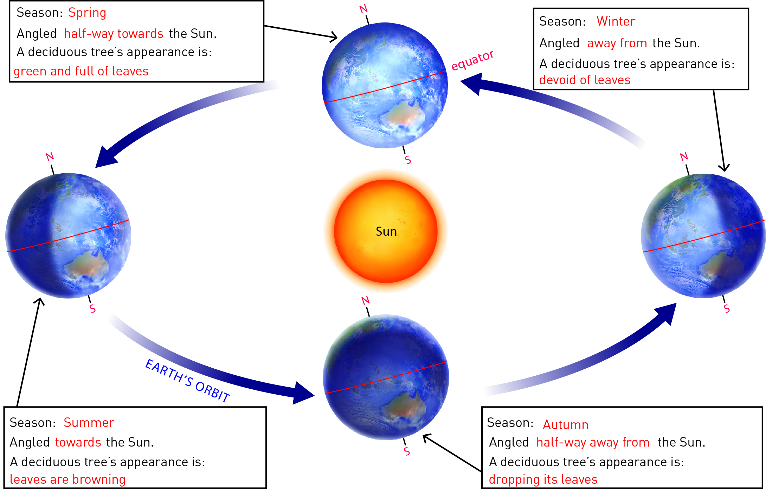

2 What is the equinox?

The equinox is the time when the Sun is directly over the equator, when day and night are of equal length. The equinox occurs twice a year.

3 What is a solstice?

The summer solstice is the longest day and shortest night, and the winter solstice is the shortest day and longest night.

4 Below is a diagram showing the Earth’s rotation around the Sun over the period of a year. There are four Earths, each representing a different season. Fill in the boxes to explain what is happening in the United States of America when the Earth is in the different positions.

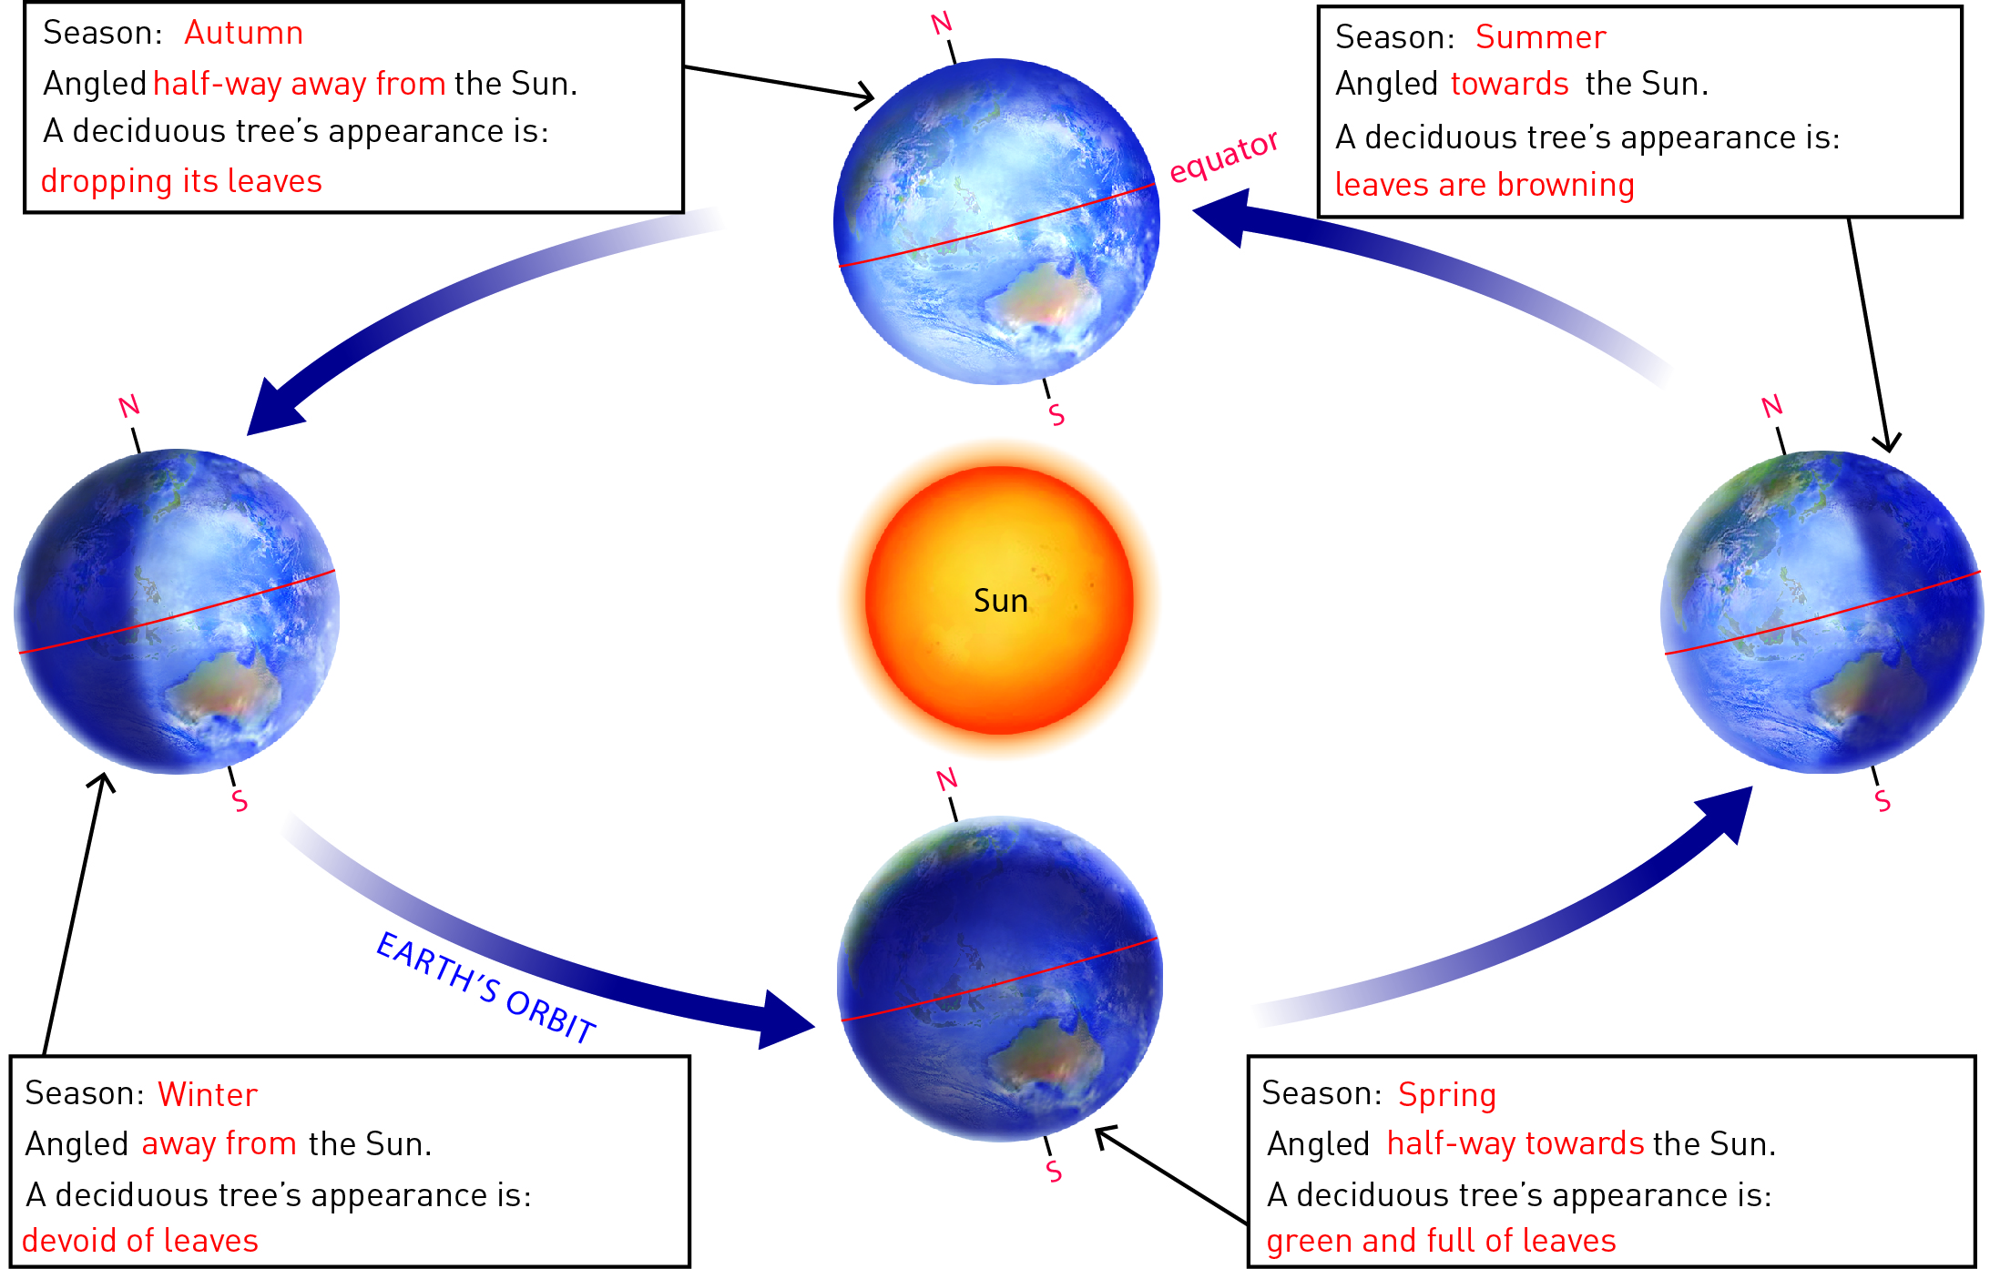

EXTEND YOUR UNDERSTANDING

5 Use the Internet to discover whether Mars has seasons. If it does:

a how long is each season?

b describe what the conditions are during the Martian summer and winter.

Like Earth, Mars experiences four seasons: winter, spring, summer and autumn. However, because the Martian year is longer than Earth’s (almost twice as long) and the axial tilt of the planet is different to that of the Earth, the length of each season differs between the northern and southern hemispheres and is different to the length of the seasons on Earth. For example, on Mars, the northern spring/southern autumn lasts for 193 sols (1 sol ≈ 24 h 40 min), the northern summer/southern winter lasts for 179 sols, the northern autumn/southern spring lasts for 143 sols and the northern winter/southern summer lasts for 154 sols.

Because of the planet’s tilt, Martian winters in the southern hemisphere are long and cold, but in the northern hemisphere they are shorter and relatively warmer. Summer mid-day temperatures average around 0°C, but can reach as high as 20°C at the equator and as low as –153°C at the poles.

9.4 Science as a human endeavour: Astronomers explore space

Student worksheet answers (pages 162–163)

Astronomy

1 List four ways that Ancient Astronomers used their observations of the stars, Sun and Moon:

• They calculated time and the best times to plant crops

• They developed calendars

• They determined the seasons

• They navigated the oceans

2 What information can be gathered using telescopes?

Telescopes can be used to gather information about distant galaxies and stars that would otherwise be impossible to get.

3 The Hubble Space Telescope observes the universe in more detail than we can from Earth.

a What forms of electromagnetic radiation can be observed by the Hubble Space Telescope?

The electromagnetic radiation that can be observed by the Hubble Space Telescope includes gamma rays, X-rays, ultraviolet radiation and light (which students may not have included).

b Describe what you know or understand about any of these forms of electromagnetic radiation.

Student responses will vary, but could include the following:

• gamma rays have the smallest wavelengths and the most energy, and are produced by the hottest and most energetic objects in the universe (e.g. supernova explosions)

• X-rays can be used in medicine to detect broken bones

• ultraviolet light comes from the Sun and can burn your skin.

4 The image to the right shows an astronaut exploring the surface of Mars. In the background you can see a moon of Mars and also the planet Earth.

a Is the image real or fake?

Fake

b What are some of the factors that helped you reach your conclusion?

Student responses will vary but could include the fact that humans have never travelled to Mars and that the Earth would be a small dot of light when viewed from Mars.

c What chemicals were detected by instruments on the *Phoenix* Mars Lander?

The Lander detected traces of magnesium, sodium, potassium and water.

EXTEND YOUR UNDERSTANDING

5 Find out what dark matteris and why it cannot be photographed.

‘Dark matter’ is the name given to matter in the universe that cannot be observed directly. Dark matter accounts for approximately 80% of the mass of the universe. It does not emit light or energy and so cannot be photographed.